A000-Eur-Constantinople-Byzantine-Cross--Bifurcate-Bronze-ΑΏΧΡ

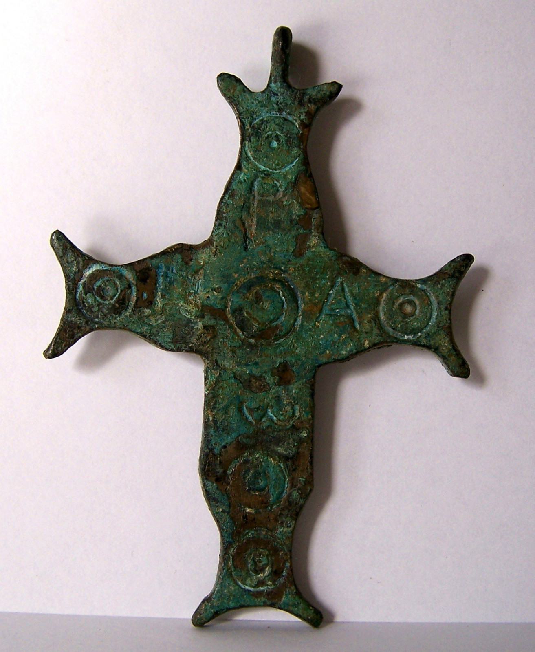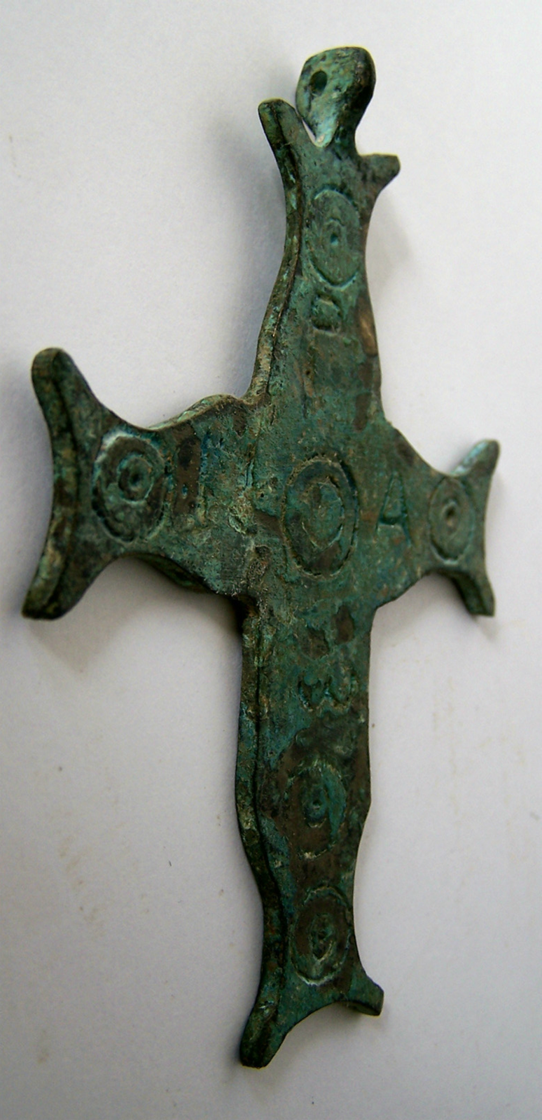

measures: 9 cm x 6 cm

Case no.:

Accession Number:

Formal Label:

**Display Description:**

**LC Classification:**

Date or Time Horizon:

Geographical Area:

**Map:**

**GPS coordinates:**

Cultural Affiliation:

Media:

Dimensions:

Weight:

Condition:

Provenance:

**Discussion:**

**References:**

| Shipping details |
| --- |
| **Ralph J Coffman Jr**  149 Atlantic Ave  Swampscott MA 01907-2427  United States |

## Order details

|  |  |  |  |
| --- | --- | --- | --- |
| **Item title** | **Available actions** | **Shipping & handling (estimated delivery*)** | **Price** |

[Printer version](http://payments.ebay.com/ws/eBayISAPI.dll?ViewPaymentStatus&transid=0&userloginid=802-867&orderid=125303748018&printerversion=true&itemid=271104286471)

|  |  |  |
| --- | --- | --- |
| Seller: | [**Member id** antiquewd](http://myworld.ebay.com/antiquewd) ( [**Feedback Score Of** 1459](http://feedback.ebay.com/ws/eBayISAPI.dll?ViewFeedback&userid=antiquewd)) | [Contact seller](http://contact.ebay.com/ws/eBayISAPI.dll?ShowCoreAskSellerQuestion&frm=3998&iid=0&redirect=0&requested=antiquewd) |

|  |
| --- |
| **Order # 125303748018**  Paid on Nov-18-12 via PayPal |

**antiquewd**

[**Member id** antiquewd](http://myworld.ebay.com/antiquewd/&_trksid=p3984.m1439.l2754) | [**Feedback Score Of** 1459](http://feedback.ebay.com/ws/eBayISAPI.dll?ViewFeedback2&userid=antiquewd&_trksid=p3984.m1439.l2776) | 98.5%

**Total items :** 17

$541.62

+$40.00

shipping

|  |
| --- |
| [**View order details**](http://payments.ebay.com/ws/eBayISAPI.dll?ViewPaymentStatus&transId=0&ssPageName=STRK:MEWNX:VPS&itemid=360512419225&_trksid=p3984.m1439.l2673) |
| [Contact seller](http://contact.ebay.com/ws/eBayISAPI.dll?ShowSellerFAQ&iid=360512419225&ssPageName=STRK:MEWNX:SCI&redirect=0&requested=antiquewd&_trksid=p3984.m1439.l2652) |
| [More actions](javascript:;) |

**Byzantine style bronze cross**



[Byzantine style bronze cross](http://www.ebay.com/itm/360512419225?ssPageName=STRK:MEWNX:IT&_trksid=p3984.m1439.l2649) (360512419225)

Your max bid: $44.00

Sale date: 11/18/12

Tracking number: --

Estimated Delivery: 11/21/12 - 11/26/12

$29.90

**Paid with PayPal on November 18, 2012.**

**Not shipped**

**Feedback not left**

**Feedback not received**

|  |
| --- |
| [**Leave feedback**](http://feedback.ebay.com/ws/eBayISAPI.dll?LeaveFeedbackShow&useridto=antiquewd&item=360512419225&transactID=0&ssPageName=STRK:MEWNX:LF&_trksid=p3984.m1439.l2665) |
| [Sell this item](http://cgi5.ebay.com/ws/eBayISAPI.dll?SellLikeItem&item=360512419225&ssPageName=STRK:MEWNX:LILT&_trksid=p3984.m1439.l2667) |
| [More actions](javascript:;) |